NAT (Static) Configuration

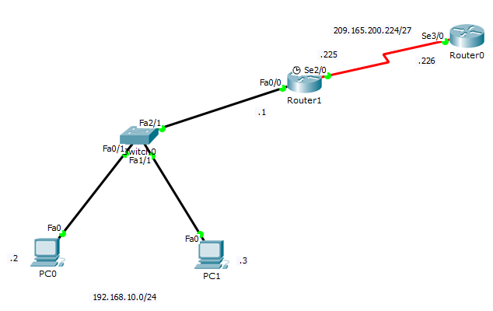

/*Configure the Router R1 (Boundary router) for Fast-Ethernet interface (Fa0/0) and Serial Interface (Ser2/0)*/
Router 1 (Configuration)# interface FastEthernet0/0
Router 1 (Configuration)# ip address 192.168.10.1 255.255.255.0
Router 1 (Configuration)# no shutdown

Router 1 (Configuration)# interface Serial2/0
Router 1 (Configuration-if)# ip address 209.165.200.225 255.255.255.224
Router 1 (Configuration-if)#clock rate 64000

/* Configure the Router R0 (ISP) for Serial Interface (Ser2/0) */
Router 0 (Configuration)# interface Serial3/0
Router 0 (Configuration-if)# ip address 209.165.200.226 255.255.255.224

/* Define static root on ISP router */
! For accessing the network 192.168.10.0/24
Router 0 (Configuration)# ip route 192.168.10.0 255.255.255.0 Serial3/0

/* Define default root on Router R1 (Boundary router) */
! For accessing the internet from network 192.168.10.0/24
Router 1 (Configuration)# ip route 0.0.0.0 0.0.0.0 Serial2/0

/* Configure NAT configuration on Router R1 (Boundary Router) */
! Define address for the NAT
Router 1 (Configuration)# ip nat inside source static 192.168. 10. 2 209.165.200.227
Router 1 (Configuration)# ip nat inside source static 192.168. 10. 3 209.165.200.228

! Define the inside interface of the router for the NAT
Router 1 (Configuration)# interface fa0/0
Router 1 (Interface)# ip nat inside
Router 1 (Interface)# no shutdown
Router 1 (Interface)# exit
! Define the outside interface of the router for the NAT
Router 1 (Configuration)# interface ser2/0
Router 1 (Interface)# ip nat outside
Router 1 (Interface)# no shutdown

#To verify the NAT configuration
Show ip nat statistics

